**5.0 Interface Design**

The user-friendly interface designs for the developing system are shown below.

**5.1 User Login Interface**

To enter the given options of UECS, users need to first register in the system. When submitting the username and password database checks the validity of entered username & password. Then it checks the user levels & provides the sign in window. Following figure shows the interface of the Sign Up & SignIn windows.



**SignUp**



**SignIn**



**5.2 Interface of Home Window**

After successfully login, user gets the home window. It consists of a scroll up window while the menu tab displays above in return link back to the sub windows which contains home, about & contact inside the home window. Once the user is login to the system, he is free to use any of the options provided by the website.

Interface after a user is sign into the system.



**5.2.1 Interface of about tab**

This tab contains all the main functions provided by the system. The following figure shows the interface of it.

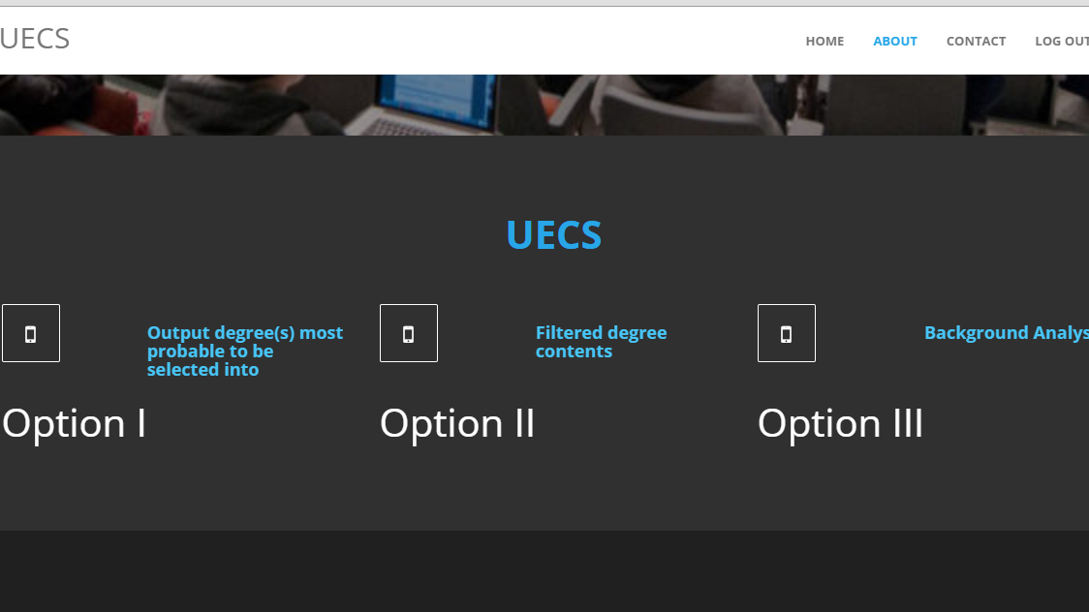

**5.2.1.1 Interface of option 1**

Here when the user request for this section the site provide him the following form to enter his details.

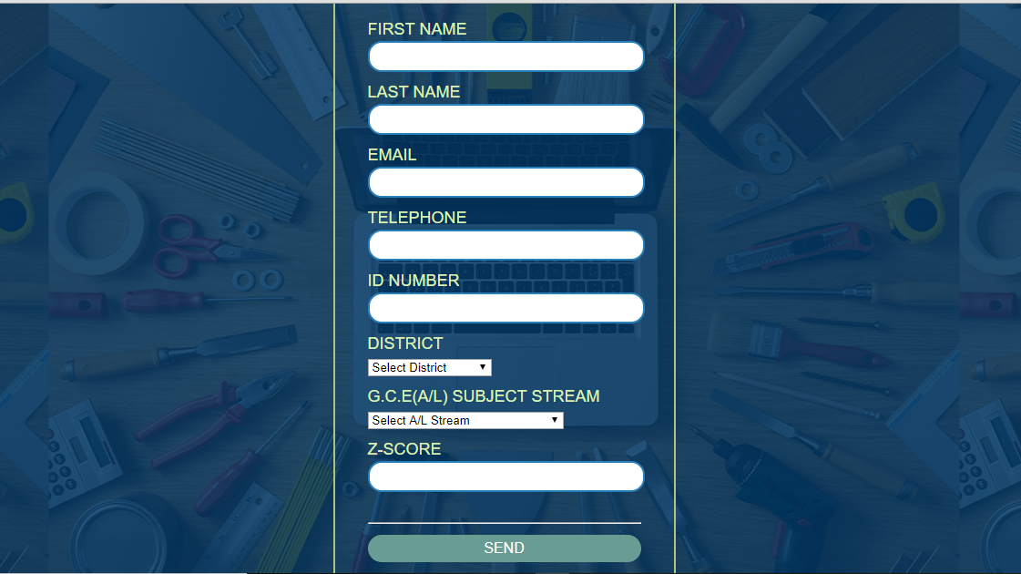

“Output degrees most probable to be selected into”

Once he/she submit the form after completing, it will be stored in the database and the prioritized degrees will be sort out from most probable to least probable order.

**5.2.1.2 Interface of option 2**

“Filtered degree content stream wise”

The same above-mentioned form is displayed as soon as the user click on this link. So, after storing data provided by the user, the database will store the data and will provide a list of degree programs that he/she is eligible with.

**5.2.1.3 Interface of option 3**

“Background research”

The user will able to get a clear idea about how the selections are made during the previous years and how the priorities are given in each university.

**5.2.2 Interface of contact tab**

Users can provide their opinions and more improvements that they are expecting from the system. Following figure shows the interface of the contact tab.

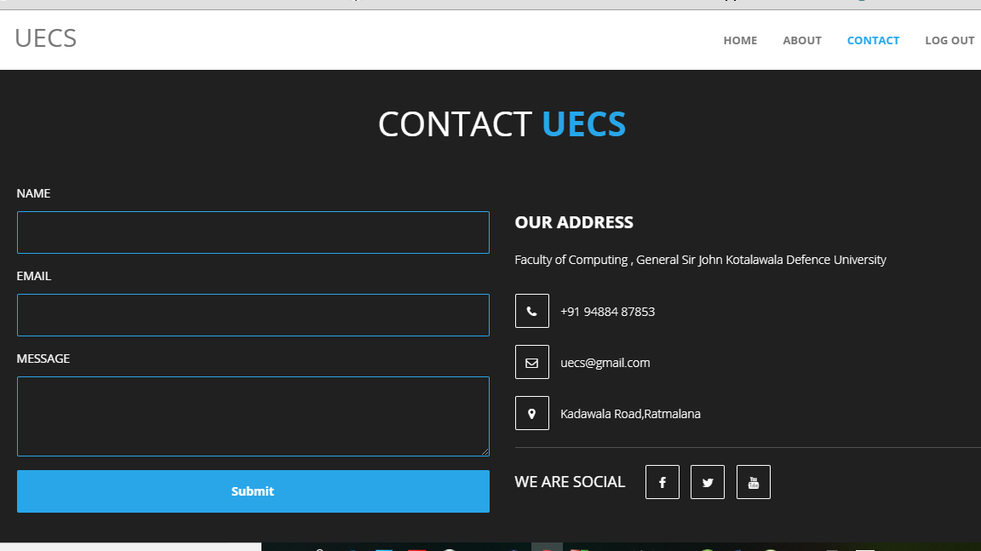

**6.0 Summary**

This document provides the Overall System Architecture, Software Architecture, Data Design & Interface Design regarding to the development of the computerized web based UECS system.

Overall architecture of this system is divided into 3 main layers namely presentation layer, application layer & data layer. Presentation layer focuses on the how the system interfaces are presented to the user while the application layer builds interaction between the presentation layer where the inputs of the interfaces and the data link layer where the required data are contained. Data layer includes the database management applications which will be helped to store data of each module. There is only one database to handle the records and this database will consist of several tables. Html will be used for the interface designing while php will be used as the scripting language for the system. phpMyAdmin & MySQL will be used as the database management application.

Software architecture of the developing system will be based on a modularized approach where system is divided into different modules. UECS will contain main 3 sections namely “Output degrees most probable to be selected into”, “filtered degree contents” & “Background analysis”. Each section will have specific functions under them.

When it comes to the data design there will be one central database using MySQL database management application hosted in the web server. Access to the database should be done through the network. An EER is modeled as for the requirements of the developing system and it is then converted into relations. Database contains several tables according to the logical design to store information about users, degrees etc. Relationships between these tables are also established according to the requirements.

All the interfaces & forms needed which are described above are designed with using html in order to produce user friendly interfaces.